Level Order Traversal.
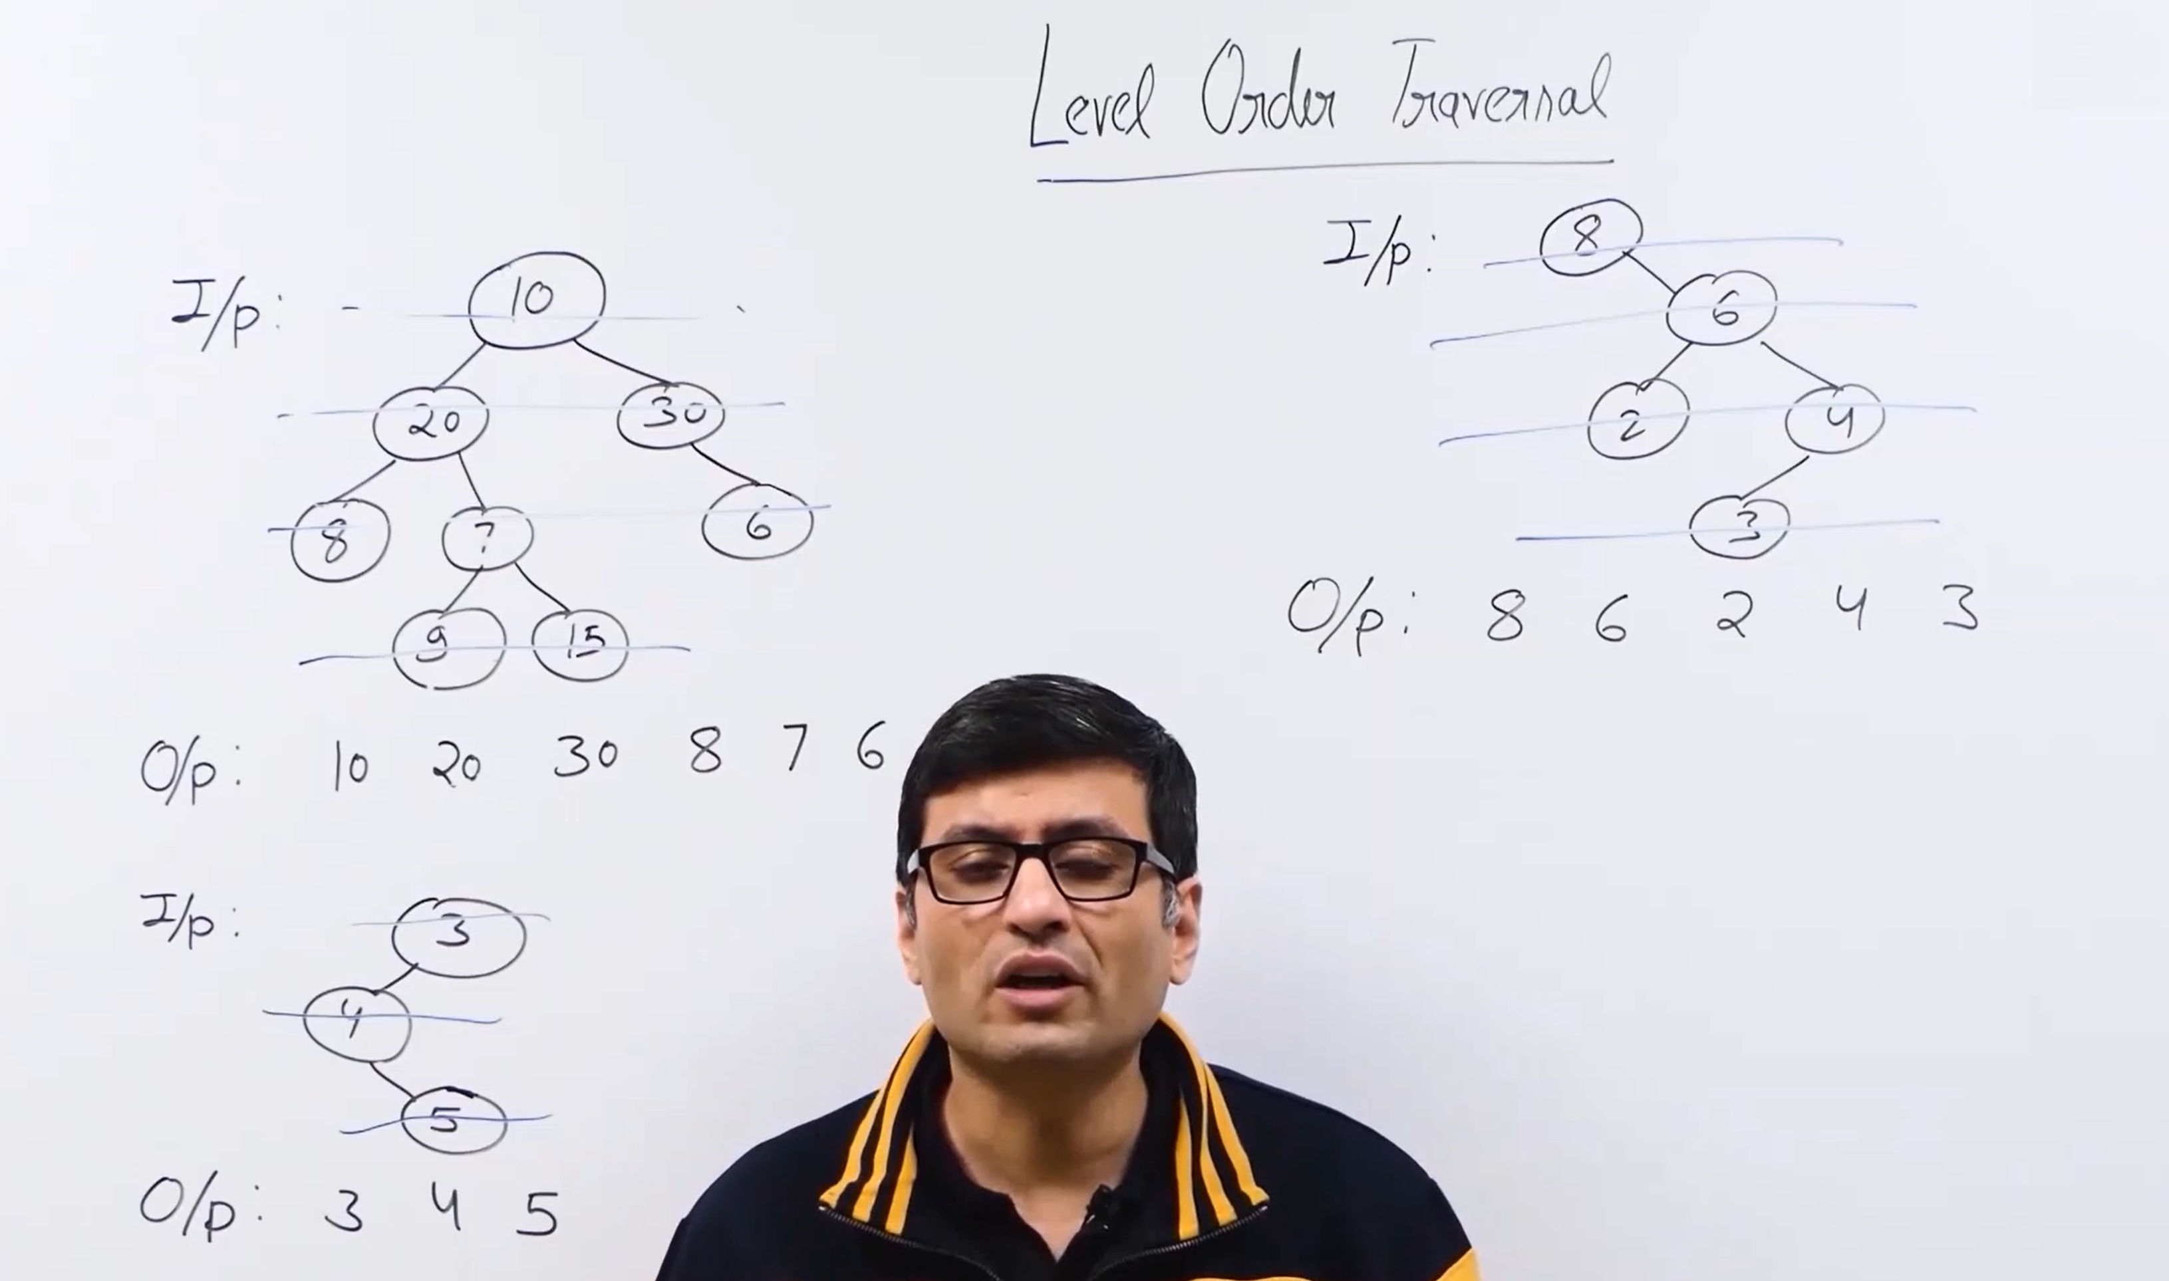
naïve approach:
The output for the solution is that both combination of the height of the binary tree and the print nodes in the distance k.
Optimal Approach:
We are using the queue for the optimal approach


